A000-Afr-Aterian Tanged Points-North Africa-Magreb Region-Middle Stone Age -100-85 ky.

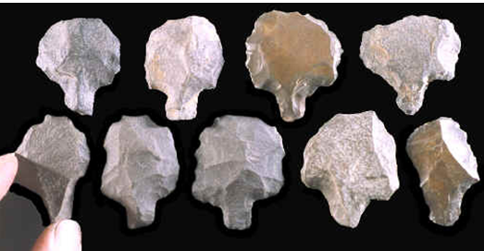

**Formal Label: Aterian Culture Tanged Points of the Magreb Region of North Africa**

**Case No. 6**

**Accession No.:**

**LC Classification:** GN775

**Date or Time Horizon:** 100,000-30,000 BP

**Geographical Area:** Maghreb region of North Africa

**Cultural Affiliation:** Aterian

**Medium:** Flint, Silicified sandstone

**Dimensions:** H 1-3 in

**Weight: varies**

**Provenance:** Morocco

**Condition:** Fine

**Discussion:**

The Aterian is a techno-complex distinguished by tanged tools that extends across North Africa for 2,500 km (1,600 mi) from the Maghreb of Morocco (where it is post-Mousterian) to the Western Desert of Egypt and the Nile valley (where it is post Levallois) (Tixier, 1967; Petit-Maire, 1982; Wendorf and Schild, 1992).

Aterian tanged tools were designed for hafting with a wooden shaft. This produced a composite tool used for knives and scrapers rather than for projectile points. This early invention of hafting occurred in the Maghreb among anatomically modern humans. One question arises: “What occasioned the invention of hafting?” In the Maghreb at ca 100,000 BP, resin–bearing trees became scarce, so hafting with a leather thong around a tang became more feasible than hafting with resin using a non-tanged lithic (see Ferring, 1975). Furthermore, these tanged tools were not used for war or hunting but for agriculture as a spade and wood-working as a chisel. Therefore, the Aterian culture was peaceful and agrarian during the Middle Paleolithic. However, there are few sites during this time-horizon in the Maghreb region of North Africa with a long stratigraphy and reliable C14 dates. One exception is the Rhafas Cave in Eastern Morocco, which has dates spanning the time horizon from >100,000 BP to 80,000 BP, and it is within this framework that the Aterian occurs (Mercier et alii 2007).

**References:**

Ferring, C.R., 1975. The Aterian in north African prehistory. *Problems in prehistory: North Africa and the Levant*, pp.113-126.

Mercier, N, L. Wengler, H. Valladas, J.-L. Joron, L. Froget, J.-L. Reyss. 2007. The Rhafas Cave (Morocco): Chronology of the Mousterian and Aterian archaeological occupations and their implications for Quaternary geochronology based on luminescence (TL/OSL) age determinations, [*Quaternary Geochronology*](http://www.sciencedirect.com/science/journal/18711014), 2:4, 309-313.

Petit-Maire, N. ed., 1982. *Le Shati: Lac pléistocene du Fezzan (Libye)*. CNRS.

Tixier, J., 1967. *Procédés d'analyse et questions de terminologie concernant l'étude des ensembles industriels du Paléolothique récent et de l'Epipaléolithique dans l'Afrique du nord-ouest*. University of Chicago Press.

Wendorf, F. and Schild, R., 1992. “The Middle Paleolithic of North Africa: a status report,” *New light on the Northeast African past*, pp.40-78.